# INTRODUCTION

# The Salesforce is your customer success platform, designed to help you sell, service, market, analyze, and connect with your customers.

# Salesforce has everything you need to run your business from anywhere. Using standard products and features, you can manage relationships with prospects and customers, collaborate and engage with employees and partners, and store your data securely in the cloud.

# So what does that really mean? Well, before Salesforce, your contacts, emails, follow-up tasks, and prospective deals might have been organized something like this:

# Problem Definition & Design Thinking

* 1. Empathy Map
  2. 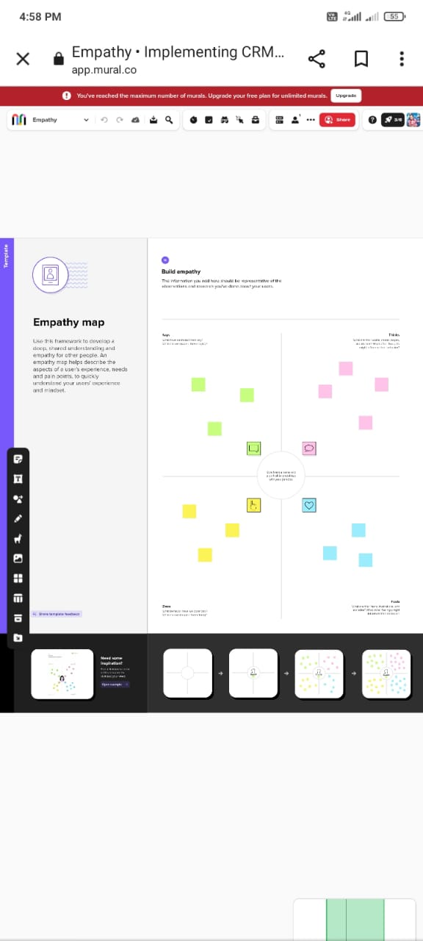
  3. Ideation & Brainstorming Map
  4. 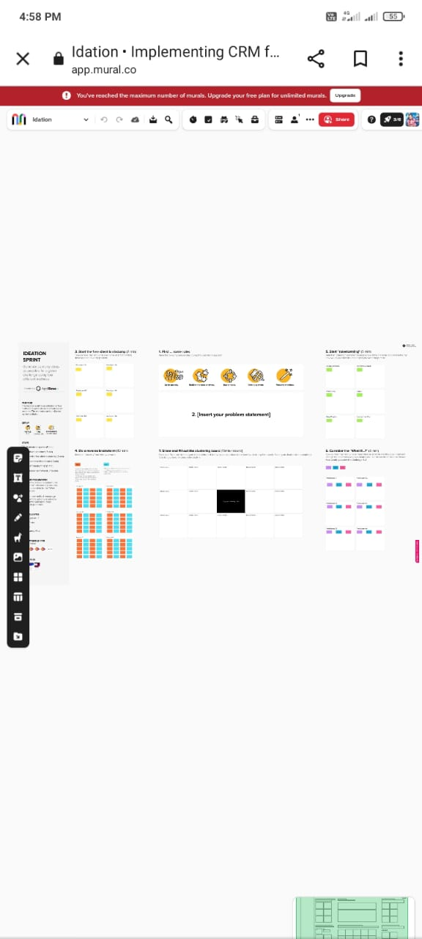

# RESULT

* 1. Data Model:

|  |  |
| --- | --- |
| **Object name** | **Fields in the Object** |
| Object 1 | |  |  | | --- | --- | | Field label | Data type | | Semester | Custom Field Definition | |
| Object 2 | |  |  | | --- | --- | | Field label | Data type | | Candidate | Custom Field Definition | |
| Object 3 | |  |  | | --- | --- | | Field label | Data type | | Course details | Custom Field Definition | |
| Object 4 | |  |  | | --- | --- | | Field label | Data type | | Lecture details | Custom Field Definition | |

# Activity & Screenshot

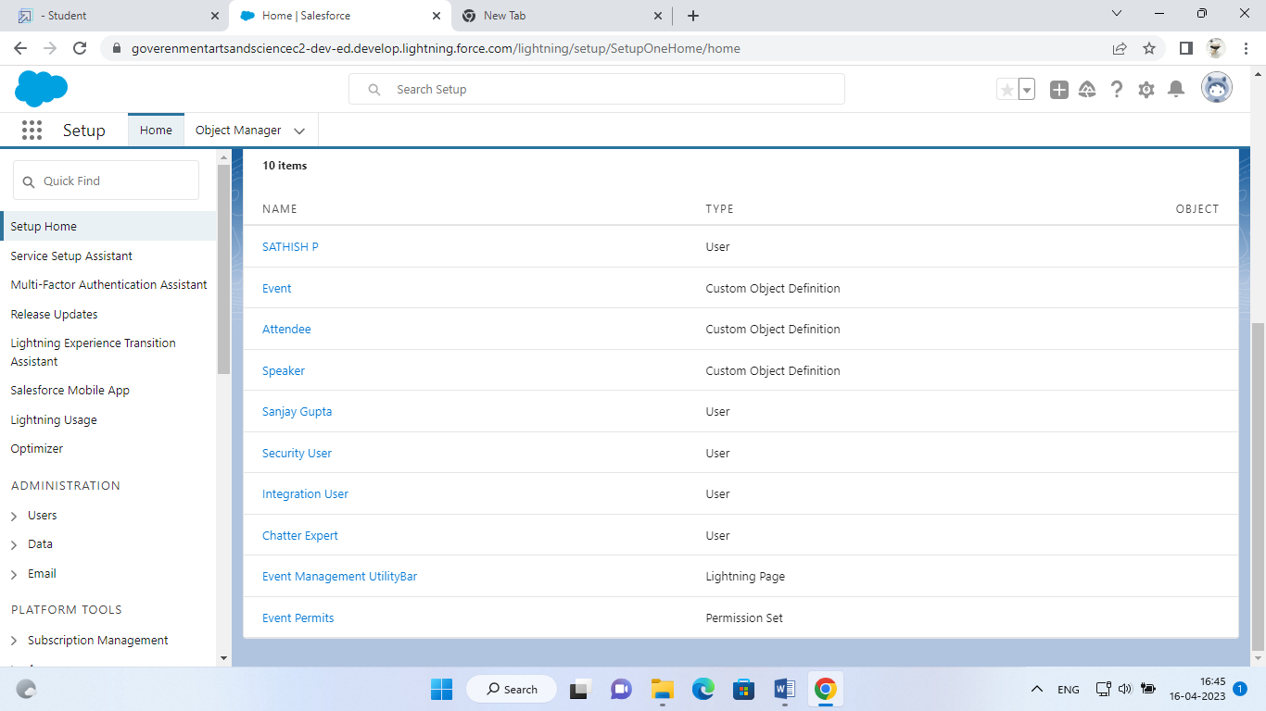

# Trailhead Profile Public URL

**Team Lead- https://trailblazer.me/id/sthala20**

1. **ADVANTAGES & DISADVANTAGE**

**ADVANTAGES OF PROPOSED SYSTEM**

• Registration for an event can be within the time

• Complete work on time

• Management of workflow can be done easily

• Increase the accessibility

**DISADVANTAGES OF THE EXISTING SYSTEM**

• Difficult to handle work manually.

• Time consuming process.

• More human power required.

APPLICATIONS

# 

### **Event Ticketing Apps**

These types of apps generate and distribute your event tickets. It enables you to sell your tickets online and collect payments for them. Some apps with advanced features can support custom selling and manage event attendance.

### **Event Scheduler Apps**

These types of apps help your guests check in on your event programs. The participants can even reschedule or cancel their bookings.

### **Survey Apps**

These apps make it easier for you to get feedback from your event participants through online polls and survey forms. The results will help you analyze the success of your events.

### **Web Conferencing Apps**

These types of apps can broadcast your event to a broader audience through live streaming.

# CONCLUSION

Trip Approval helps businesses enforce travel policies, stop overspending on airfare and hotels, see when there's travel to high-risk destinations, and save managers from having to request new itineraries.